www.transmate.com.au

Has your business changed? We can modify Transmate to suite. Whatever your needs are we can help. Call us on 0352573388 or email rob@transmate.com.au to discuss.

Transmate also has additional functionality to handle:

- Web portal to add new job bookings and check POD status
- Planner / scheduler for viewing truck / driver availability and jobs in progress
- Mobile despatch with electronic POD’s
- Multi-leg within consignment functionality

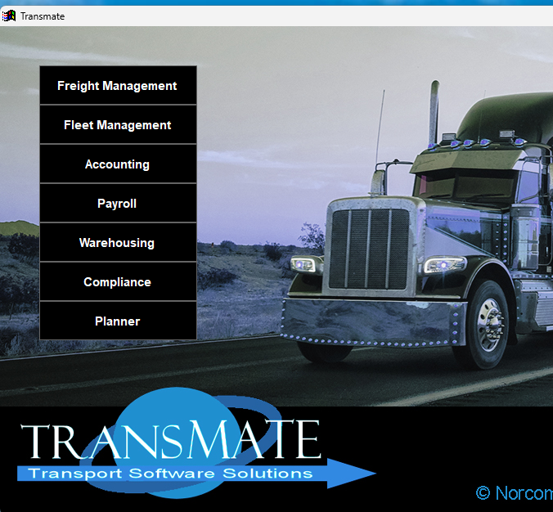

Transmate Online – customer web portal

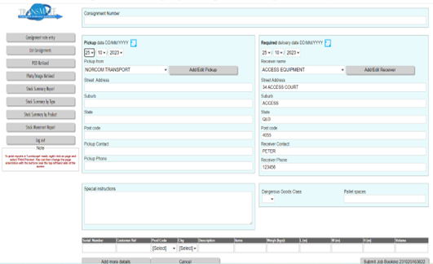

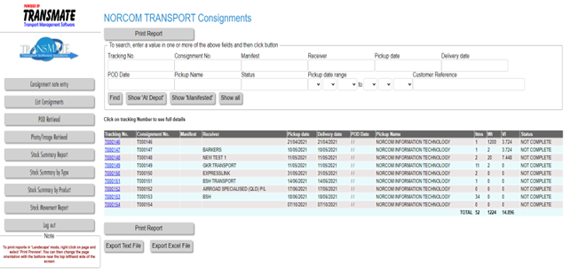

Planner / Scheduler calendar

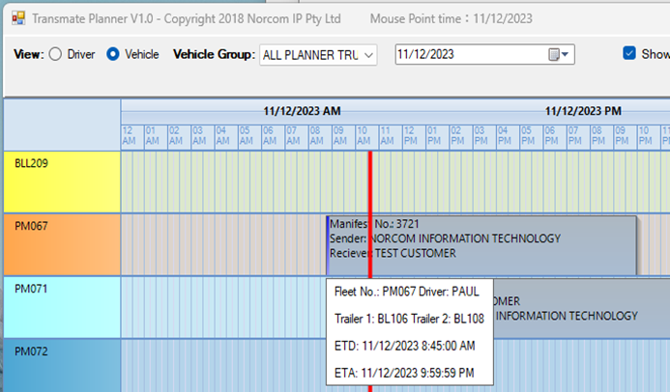

Mobile despatch with electronic sign on glass POD
